Handout Name：

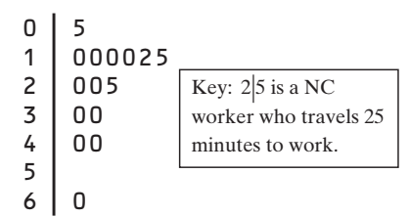

【NC workers】Determine whether there are outliers

【Shoes】How many pairs of shoes does a typical teenage boy own? To find out, two AP® Statistics students surveyed a random sample of 20 male students from their large high school and recorded the number of pairs of shoes that each boy owned. Here are the data, along with a dotplot:

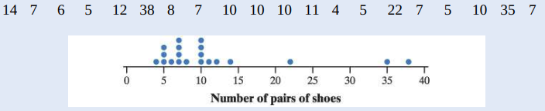

Describe the procedure for identifying outliers, and use the procedure to decide whether there are outliers.

【NY workers】New York travel time data:

10 30 5 25 40 20 10 15 30 20 15 20 85 15 65 15 60 60 40 45

Draw a boxplot for this set of data.

